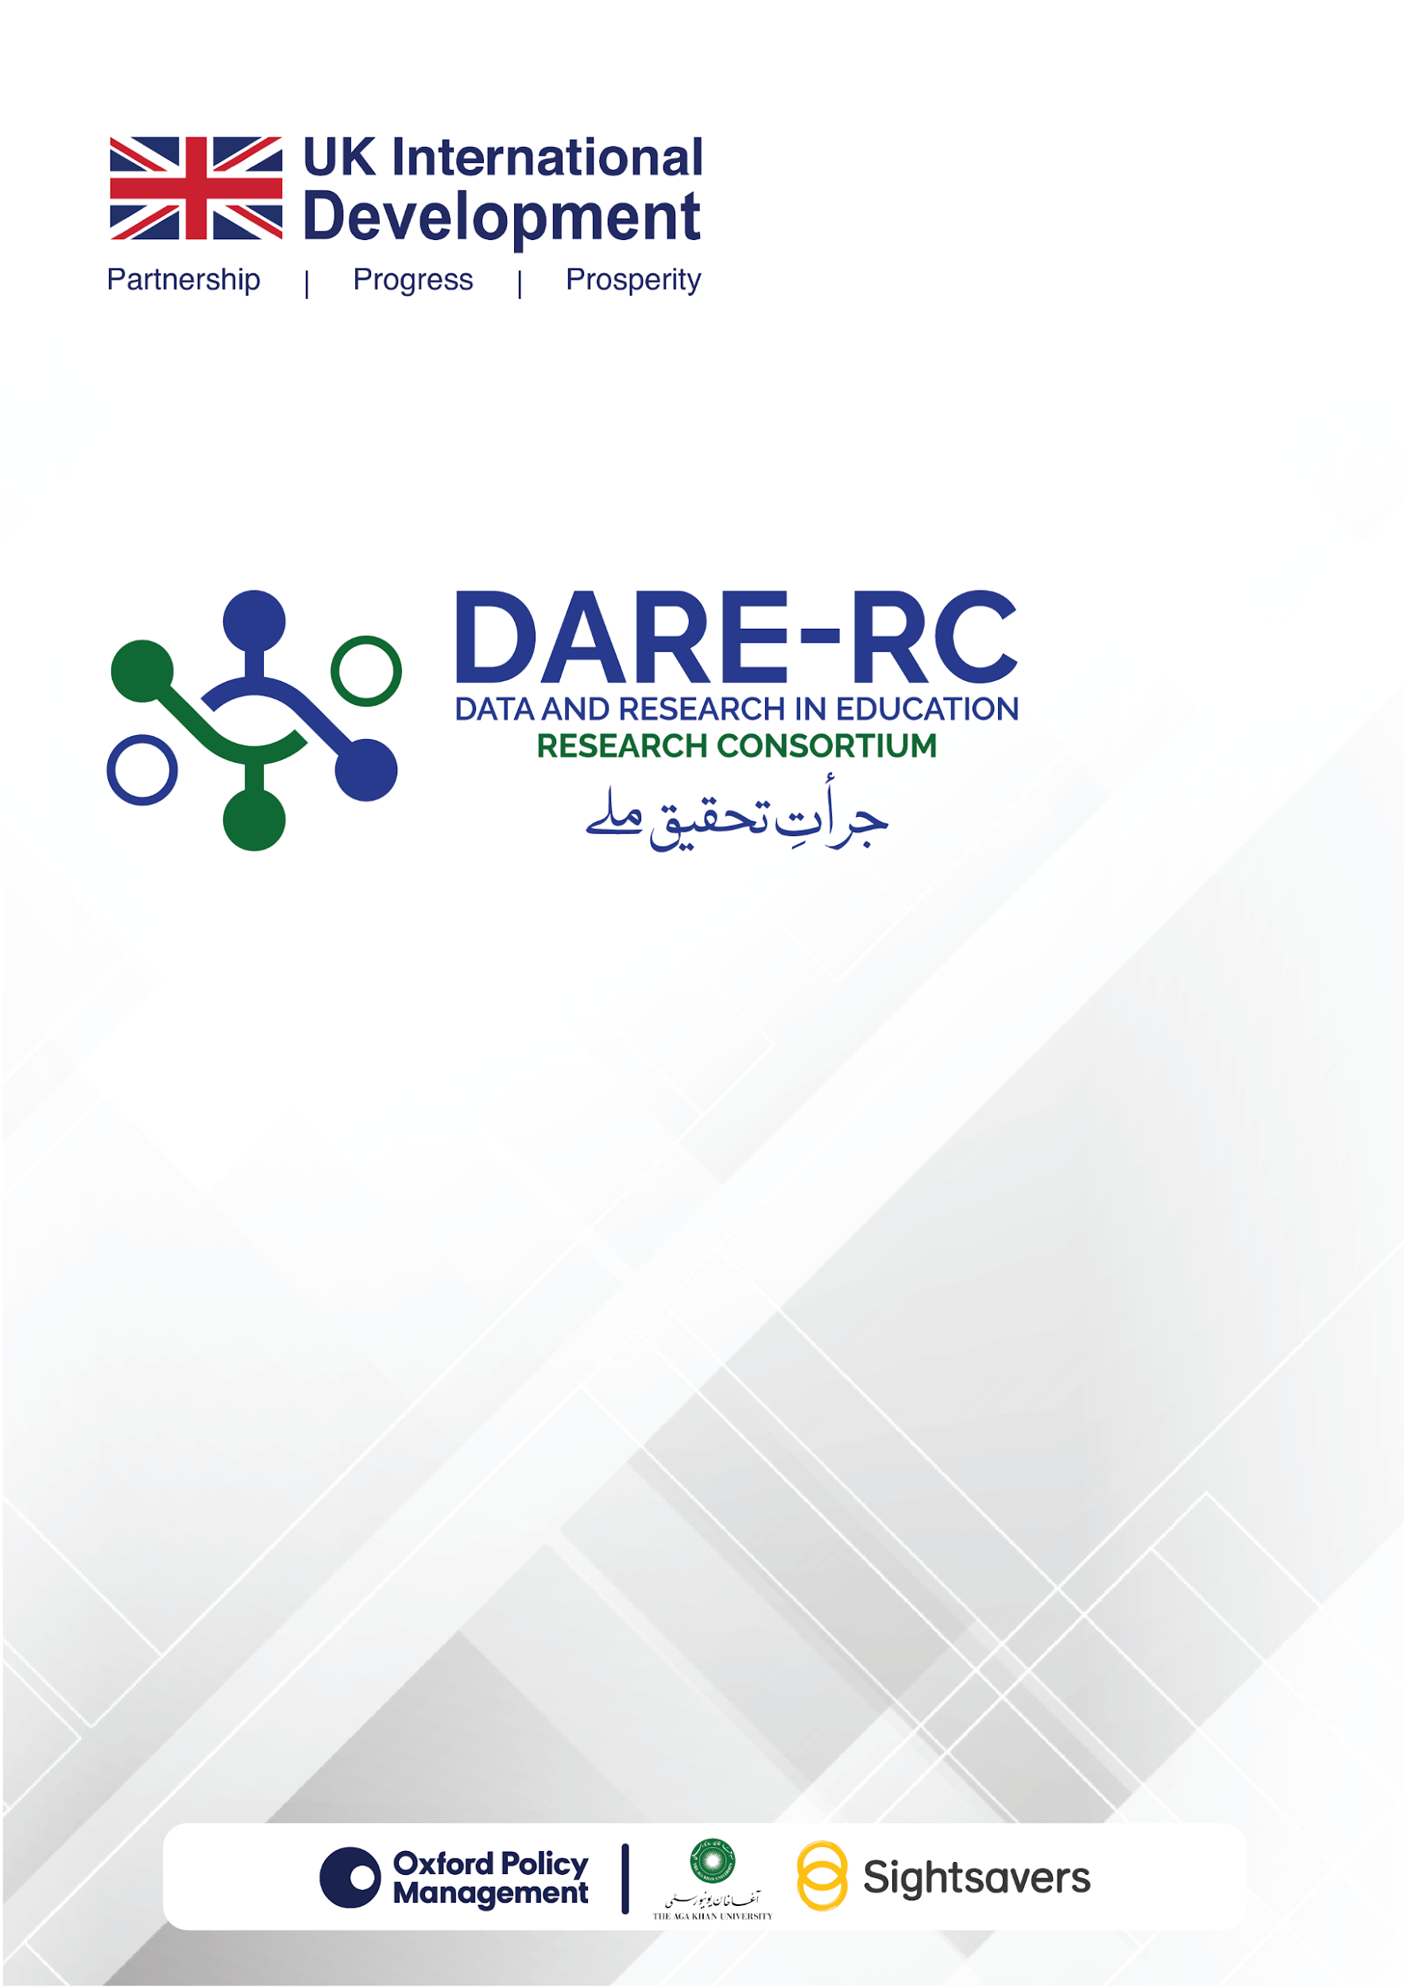
DARE-RC
Call for Applications - Cycle 4

DARE-RC RESEARCH PROPOSAL TEMPLATE AND GUIDELINES

Table of Contents
1. Project Summary Information 3
1.1. Project Title: 3
1.2. Programme of Work: 3
1.3. Project Start and Completion Dates: 3
2. Lead Organisation and Project Team 3
2.1. Lead Organisation: 3
2.2. Other FCDO Contracts: 3
2.3. Lead Investigator: 3
2.4. Co-Investigators: 4
3. Project Details (750 words) 4
3.1. Project Summary (max. 200 words): 4
3.2. Staff Duties (max. 150 words): 4
3.3. Policy Engagement Plan (max. 150 words): 4
3.4. Value for Money (max. 100 words): 5
3.5. Ethics Statement and Plan (max. 150 words): 5
4. Main Proposal (1,750 words) 5
4.1. Research Questions or Problems (max. 200 words): 5
4.2. Relevance to Policy and Practice (max. 250 words): 6
4.3. Research Context (max. 200 words): 6
4.4. Literature Review (max. 500 words): 6
4.5. Research Methodology (max. 500 words): 6
4.6. Project Management: 7
4.7. Risk Mitigation Plan (max. 100 words): 8
4.8. References: 8
5. Documents to be Attached 8
5.1. CVs: 8
5.2. Budget Template: 8
5.3. Budget Justification: 8
5.4. Statements of Purpose: 8
5.5. Conflict of Interest Form: 8
5.6. Checklist: 9

DARE-RC Research Proposal Template and Guidelines
The research proposal should be submitted by the deadline mentioned in the DARE-RC Call for Applications – Cycle 4 document. The research proposal should provide a comprehensive overview of the research study to be conducted, and it should include five sections, as detailed below.

Note: All documents should be in standard Times New Roman font and size 11 (1.15 spacing).

The research proposal will have five sections:
- Project summary information
- Lead organisation and project team
- Proposal details
- Main proposal
- Documents to be attached
Key Information about the Applicant Organisation: Please provide the following information.
Name of Applicant Organisation: | Geographical Scope: (where will the research be conducted in Pakistan):
Type of Applicant Organisation (Public, Private, Research Think Tank, NGO, Others-please specify): | Address of Applicant Organisation:
Contact Number of Applicant Organisation: | Name & Email Address of Lead Investigator (s):
Applicant organisation’s website address: | In case of Joint Venture-please specify the name(s) of the other partner entities:
Application Number (If this is the first application, please enter “1” and continue the sequence accordingly for multiple applications):

Project Summary Information

Project Title:
Please provide a title for your project; a project acronym is not required, but the title should be succinct enough that your project can be referred to easily.

Programme of Work:
Please mention the most relevant topic being covered from the suggested list of topics for research studies, provided in the Call 4 document (see Annex 1).
Total Budget:
Please include the total budget here in PKR that you are requesting. The figure provided here must match the total in the Excel budget template.

Project Start and Completion Dates:
Please provide the intended start and end dates for the project, noting that projects will last for no more than 06 - 08 months for research studies.

Lead Organisation and Project Team

Lead Organisation:
Please provide details of the lead organisation that will manage the project. DARE-RC will contract this organisation to complete the project, and the lead organisation will be responsible for establishing contractual arrangements with any other organisations funded by the project. In case of a consortium being formed, please provide the brief details of the other organisations.

Other FCDO Contracts:
You must state whether your organisation currently is a party to any other contracts with the UK FCDO and note the value of these contracts within broad ranges (i.e. under £1 million, between £1 million and £5 million, or over £5 million). This information is required for us to assess the level of due diligence and compliance checks that will be required should your application be successful (though a full due diligence process will be conducted irrespective of the existence of previous contracts).

Lead Investigator:
Please provide the name of the lead investigator for the project. The named lead investigator or a member of the research team should have a formal association with the lead organisation that will outlast the length of the project you are proposing.

Co-Investigators:
Provide the names and current organisational affiliation of all the co-investigators of your study.

Project Details (750 words)
In this section, you are required to provide information on various aspects of your research project.

Project Summary (max. 200 words):
Please provide a summary of your project and its key outputs. This should be written in simple English. We may use the project summary text in communications about the programme should your application be successful.

Staff Duties (max. 150 words):
In this section, you should summarise the roles and responsibilities of each individual working on the project. This should include the principal and co-investigators, as well as other project staff, whether named or unnamed. This section should justify the amount of time dedicated to the project by each team member and will be used in the value for money assessment of your project. It should also note the lines of responsibility and accountability among staff on the project.

Policy Engagement Plan (max. 150 words):
In this section, you should outline the steps you will take to maximise the value and use of your project’s outputs to stakeholders. This should include stakeholder engagement activities, communication, and outreach. We recognise that the outcomes of any research project are uncertain by definition; however, your ‘policy engagement plan’ should identify likely outcomes and how these can lead to impact, as well. Specifically, proposals should include a brief engagement plan and a publication plan and list of the target audience for the dissemination of research products for DARE-RC’s action. This section should include the following:
- A description of which stakeholders (for example, relevant government offices, academics) will be engaged throughout the research process, and how they will be engaged.
- How will the findings of the study be disseminated in terms of roundtables, seminars, webinars, community events, government presentations and website blogs?
- Who should be the target audiences of the findings (for example, government, policymakers, academia, civil society, education sector organisations)? This is needed to enable DARE-RC to plan relevant dissemination activities.
- A publication plan describing what kind of publications will result from this research and where these will be published (i.e. academic journals).

Value for Money (max. 100 words):
This statement should explain why your project proposal constitutes good value for money. The value for money statement should address two issues:
- The extent to which the likely outcome of the research will represent value for money, and in particular the relationship between the funds that are sought and the significance and quality of the projected outcomes of the research.
- Whether the resources requested are reasonable in the context of the proposed research and its scope, considering economy, efficiency, effectiveness, and equity.

Ethics Statement and Plan (max. 150 words):
In this section, you should provide details of any ethical issues arising from your project and how they will be managed. This should include a description of institutional or other ethics review processes which will be used to seek ethical clearance for the proposed study. We would expect all field research and any secondary data analysis that could involve personally identifiable information to undergo an ethics review process through a notified body.

Main Proposal (1,750 words)
This is the main part of your proposal. It should be no more than 1,750 words, excluding references but including footnotes and endnotes. It should provide the required information needed to assess your full proposal under the headings given below. You are expected to follow the sequence and word count. Information beyond the given word limit will not be considered in the evaluation of the respective section.

Research Questions or Problems (max. 200 words):
You should clearly describe the research and methodological questions you are intending to address, and how these relate to the DARE-RC’s priority areas and the identified topics (Annex 1) in the DARE-RC Call for Applications – Cycle 4 document. The following guidelines for framing research questions should be considered:

- Inclusivity:
You should consider whether and how the proposed research may address the needs of specific marginalised groups (such as gender, religious minorities, refugees), disadvantaged, and vulnerable communities.
- Gender responsiveness:
Proposals should outline how their proposed research questions and outcomes will be analysed by gender, and what gender-specific evidence and policy recommendations they will provide.
- Transferability:
You should consider how the proposed research questions and evidence generated will hold relevance and applicability for the contexts and backgrounds similar to where the research is being conducted (for example, elsewhere in Pakistan, in the South Asian region, in developing countries). The proposal should identify such countries/regions and describe which findings from the study are relevant to other contexts and how.

Relevance to Policy and Practice (max. 250 words):
In this section, you should summarise how your project will be beneficial to decision makers and/or practitioners in Pakistan on what works to deliver educational access, quality, continuity and coherence to improve learning outcomes, at scale, for all children in Pakistan, especially those most marginalised. If it is applicable, add the potential benefit and relevance of your research for the global evidence base. You should specifically discuss the relevance of your project has to the education priorities at the provincial and federal levels. Strong proposals will cite specific demand from policymakers or practitioners in Pakistan for the work outlined in the application. This section should also describe the ultimate beneficiaries of the project’s work.

Research Context (max. 200 words):
Here, you should describe how your proposed research question/s are important for addressing pertinent education issues in your research context. This section will present an analytical perspective of the geographical, social, historical, and cultural context within which the research will be conducted.

Literature Review (max. 500 words):
You should provide a critical analysis of relevant literature with a clear identification of the knowledge gap. Explain how the proposed research seeks to address the identified knowledge gaps with reference to the existing local, national, and relevant international literature and policy space.
Also, specify the theoretical framework and concepts underpinning the research study, methodology, and analysis.

Research Methodology (max. 500 words):
You should describe the methods that will be used to carry out your research and highlight how these represent innovation in the field. This section should explain why this methodological approach is appropriate for addressing the research questions you have set out. In case of using a mixed methods approach, please specify the model and level of integration of different sets of data and analysis.
Specify the localities in which the field work will be carried out for gathering data. You should provide details of the sampling techniques, data sources that will be used, and how the data will be analysed to generate research findings.
The sampling strategy should be well planned and should consider the following:

- Quantitative sampling:
- Specify the total sample size for each type of data used and specific techniques that will be employed to draw the sample (e.g. stratified sample, sampling proportional to size).
- Provide a rationale for using the sampling methodology by explaining how the sample size and strategy will be appropriate for testing the proposed hypotheses. Provide the statistical basis and calculations to justify that the sample is representative of the target population and adequate to detect the hypothesised effects.

- Qualitative sampling:
- Provide the total sample size and breakdown of the target sample for qualitative data (for example, the number of interviews or focus groups to be conducted, the number of respondents in a focus group).
- Describe the demographic composition of the sample to be targeted for qualitative data collection (i.e. gender, types of respondents).
- Provide justification for, or references for, choosing the sampling strategy, and explain how the sample size, composition, and strategy will be appropriate and how it is adequate and representative.
- Considerations for sampling:
- Inclusivity: If the research questions cater to gathering evidence and presenting policy solutions for specific marginalised or disadvantaged groups, describe what strategy will be used to incorporate these groups in the sample.
- Gender responsiveness: The sampling strategy should clearly outline how the sample is distributed across gender and how that will allow estimates and results to be disaggregated by gender.

Project Management:
A Gantt Chart should be used to illustrate the project timeline, providing a clear visual representation of the study’s schedule, progress and milestones.

Risk Mitigation Plan (max. 100 words):
You should identify key risks associated with the project delivery and other critical issues, including safeguarding, anti-fraud, bribery, and corruption using a risk matrix (table). For each risk, suggest a mitigation strategy to address potential challenges effectively, ensuring the project's integrity and adherence to ethical standards.

References:
The proposal should follow APA (7th ed.) for writing style and references.

Documents to be Attached

CVs:
You should attach a single PDF file including the CVs of all members of the core research team, including the principal investigator and co-investigator(s). Each CV should be no more than two pages in length and should include recent relevant scholarly outputs. We recognise that some junior staff may be identified and appointed after the project has been selected for funding.

Budget Template:
You are required to attach a complete budget, in accordance with the Excel template provided by the DARE-RC. Guidance on how to complete this template is provided in a separate guidance document.
Release of payments will be made on approval of milestones by DARE-RC. Contracts with suppliers will mirror OPM’s contract terms with the FCDO.

Budget Justification:
You should attach a one-page document which provides a justification of all costs included in your budget, following the budget guidance.

Statements of Purpose:
Please attach any statements of support that are required to assess the feasibility of your project. These must include statements from the research office or senior management of any organisation named in the project or with which research team members have an association. They should also include a letter of support from any organisations whose cooperation is required for the delivery of the project, such as implementing agencies or data owners. General letters of support from stakeholders that are not essential for the delivery of the project’s research outputs should not be included.

Conflict of Interest Form:
Please attach the duly filled Conflict of Interest form here for the Lead Investigator and Co-Investigators.

Checklist:
Please check if the following supporting documents have been duly attached with your technical and financial proposals:
REMINDER to Applicant Organisation:
In addition to the documents listed above i.e. the CVs of core research team including Principal Investigator and Co-Investigators, Conflict of Interest Forms of the Principal Investigator and Co-Investigators, and the Budget and Budget Justification, the applicant organisation must also submit the following Supporting Documents, in accordance with Section 7 of the Call for Applications Cycle-4.

- Basic profile of the organisation focusing on completed and ongoing relevant research projects and other activities including the details like funding institution, research study area, geographical area, total budget etc. This is to be no longer than five pages.
- Copy of Valid Registration Certificate (for private organisations) or a copy of Byelaws or relevant law, act or other document under which a public sector organisation is registered (for public sector organisations).
- Complete auditor’s report (including audited financial statements) for the years 2023 and 2024 (applicable to both public and private sector organisations).
- In cases where public sector organisations do not have the above-mentioned audited financial statements and auditor’s reports, they may submit any two audit reports issued by the relevant office of the Auditor General of Pakistan/or the relevant authority between 2022 and 2025.
- Tax registration certificate.
- Links to/submission of at least two recent peer-reviewed publications relevant to the priority areas and research topics given above: these publications can be authored by any of the key members of the research team.
- CVs (not more than two-pages each) of core research team (including Lead Investigator/Researcher and co-investigators) - and list of publications of the Lead Investigator/Researcher and co-investigators demonstrating experience of leading and conducting high-quality research in education/social sciences.
- A confirmation on the applicant organisation’s letterhead, signed by the competent authority of the applicant organisation, stating that it will obtain a No Objection Certificate (NOC) for conducting field data collection under the DARE-RC grant.
- A confirmation on applicant organisation’s letterhead, signed by the competent authority of the applicant organisation stating, “that the applicant organisation is not bankrupt or currently involved in any litigation related to bankruptcy”.
- A confirmation on applicant organisation’s letterhead, signed by the competent authority of the applicant organisation stating, “that the applicant organisation is not suspended, or debarred, or otherwise identified as ineligible by FCDO, OPM, or any other organisation”.

For details on the above supporting documents and their preparation and compliance, please refer to Section 7 of the Call for Applications – Cycle 4 document.

