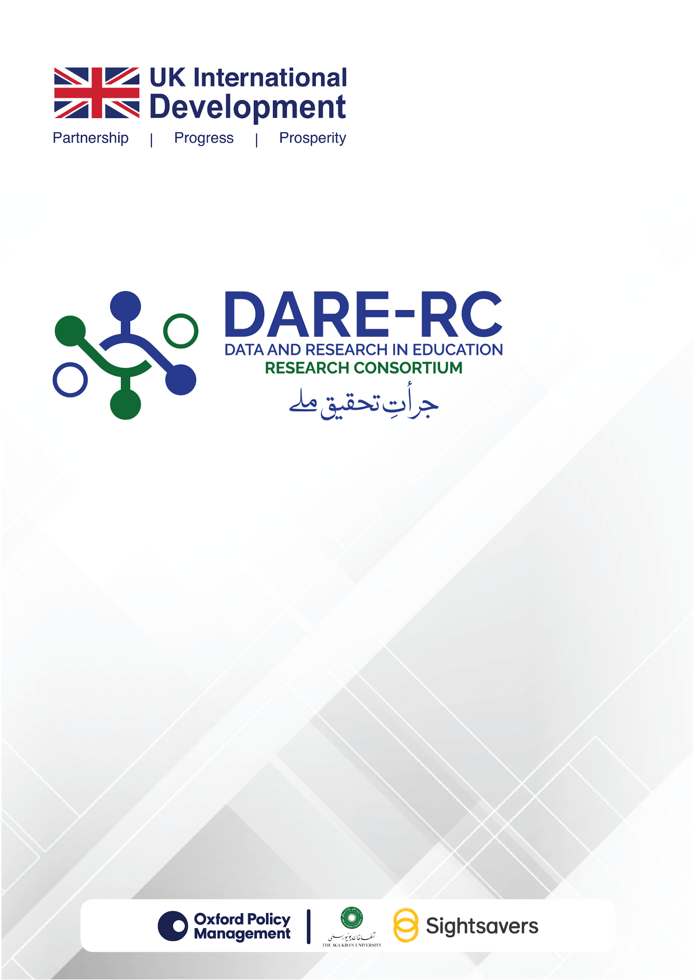
DARE-RC
Call for Applications - Cycle 4

DARE-RC SCOPING PAPER/EVIDENCE SYNTHESIS TEMPLATE AND GUIDELINES

Table of Contents
1. Project Summary Information 3
1.1. Project Title: 3
1.2. Programme of Work: 3
1.3. Project Start and Completion Dates: 3
2. Lead Organisation and Project Team 3
2.1. Lead Organisation: 3
2.2. Other FCDO Contracts: 3
2.3. Lead Investigator: 3
2.4. Co-Investigators: 4
3. Project Details (500 words) 4
3.1. Project Summary (max. 100 words): 4
3.2. Staff Duties (max. 100 words): 4
3.3. Policy Engagement Plan (max. 100 words): 4
3.4. Value for Money (max. 100 words): 5
3.5. Ethics Statement and Plan (max. 100 words): 5
4. Main Proposal (1000 words) 5
4.1. Introduction (max. 350 words): 5
4.2. Guiding Research Questions (max. 50 words): 6
4.3. Proposed Methodology (max. 400 words): 6
4.4. Proposed Timeline and Workplan (max. 100 words): 6
4.5. Risk Mitigation Plan (max. 100 words): 7
4.6. References: 7
5. Documents to be Attached 7
5.1. CVs: 7
5.2. Budget Template: 7
5.3. Budget Justification: 7
5.4. Statements of Purpose: 8
5.5. Conflict of Interest Form: 8
5.6. Checklist: 8

DARE-RC Scoping Paper/Evidence Synthesis Template and Guidelines

The scoping paper/evidence synthesis proposal should be submitted by the deadline mentioned in the DARE-RC Call for Applications – Cycle 4 document. The scoping paper/evidence synthesis proposal should include five sections, as detailed below.
Note: All documents should be in standard Times New Roman font and size 11 (1.15 spacing).

The scoping paper/evidence synthesis proposal will have five sections:
- Project summary information
- Lead organisation and project team
- Proposal details
- Main proposal
- Documents to be attached
Key Information about the Applicant Organisation: Please provide the following information.
Name of Applicant Organisation:

Type of Applicant Organisation (Public, Private, Research Think Tank, NGO, Others-please specify): | Geographical Scope (where will the research be conducted in Pakistan):
Address of Applicant Organisation: | Contact Number of Applicant Organisation:
Applicant Organisation’s website address: | Name & Email Address of Lead Investigator (s):
Application Number (If this is the first application, please enter “1” and continue the sequence accordingly for multiple applications): | In case of Joint Venture-please specify the name(s) of the other partner entities:

Project Summary Information

Project Title:
Please provide a title for your project; a project acronym is not required, but the title should be succinct enough that your project can be referred to easily.

Programme of Work:
Please mention the most relevant topic being covered from the suggested list of topics for scoping paper/evidence synthesis, provided in the Cycle 4 document (see Annex 2).
Total Budget:
Please include the total budget here in PKR that you are requesting. The figure provided here must match the total in the Excel budget template.

Project Start and Completion Dates:
Please provide the intended start and end dates for the project, noting that projects will last for no more than 04 - 06 months for scoping paper/evidence synthesis.

Lead Organisation and Project Team

Lead Organisation:
Please provide details of the lead organisation that will manage the project. DARE-RC will contract this organisation to complete the project, and the lead organisation will be responsible for establishing contractual arrangements with any other organisations funded by the project. In case of a consortium being formed, please provide brief details of the other organisations.

Other FCDO Contracts:
You must state whether your organisation is currently a party to any other contracts with the UK FCDO and note the value of these contracts within broad ranges (i.e. under £1 million, between £1 million and £5 million, or over £5 million). This information is required for us to assess the level of due diligence and compliance checks that will be required should your application be successful (though a full due diligence process will be conducted irrespective of the existence of previous contracts).

Lead Investigator:
Please provide the name of the lead investigator for the project. The named lead investigator or a member of the research team should have a formal association with the lead organisation that will outlast the length of the project you are proposing.

Co-Investigators:
Provide the names and current organisational affiliation of all the co-investigator(s) of your project.

Project Details (500 words)
In this section, you are required to provide information on various aspects of your scoping paper/evidence synthesis project.

Project Summary (max. 100 words):
Please provide a summary of your project and its key outputs. This should be written in simple English. We may use the project summary text in communications about the programme should your application be successful.

Staff Duties (max. 100 words):
In this section, you should summarise the roles and responsibilities of each individual working on the project. This should include the principal and co-investigators, as well as other project staff, if any, whether named or unnamed. This section should justify the amount of time dedicated to the project by each team member and will be used in the value for money assessment of your project. It should also note the lines of responsibility and accountability among staff on the project.

Policy Engagement Plan (max. 100 words):
In this section, you should outline the steps you will take to maximise the value and use of your project’s outputs to stakeholders. This should include stakeholder engagement activities, communication, and outreach. We recognise that the outcomes of any scoping paper/evidence synthesis project are uncertain by definition; however, your ‘policy engagement plan’ should identify likely outcomes and how these can lead to impact, as well. Specifically, proposals should include a brief engagement plan and a publication plan and list of the target audience for the dissemination of scoping/synthesis products for DARE-RC’s action. This section should include the following:
- A description of which stakeholders (for example, relevant government offices, academics) will be engaged throughout the scoping paper/evidence synthesis development process, and how they will be engaged.
- How will the findings of the paper be disseminated in terms of roundtables, seminars, webinars, community events, government presentations, and website blogs?
- Who should be the target audiences of the findings (for example, government, policymakers, academia, civil society, education sector organisations)? This is needed to enable DARE-RC to plan relevant dissemination activities.
- A publication plan describing what kind of publications will result from this scoping/synthesis review and where these will be published.

Value for Money (max. 100 words):
This statement should explain why your project proposal constitutes good value for money. The value for money statement should address two issues:
- The extent to which the likely outcome of the scoping paper/evidence synthesis will represent value for money, and in particular the relationship between the funds that are sought and the significance and quality of the projected outcomes of the paper.
- Whether the resources requested are reasonable in the context of the proposed scoping paper/evidence synthesis and its scope, considering economy, efficiency, effectiveness, and equity.

Ethics Statement and Plan (max. 100 words):
In this section, you should provide details of any ethical issues arising from your project and how they will be managed. This should include a description of measures to be followed for ethical conduct of the study. We would expect all field research, if any, and any secondary data analysis that could involve personally identifiable information, to undergo an ethics review process through a notified body.

Main Proposal (1000 words)
This is the main part of your proposal. It should be no more than 1000 words, excluding references but including footnotes and endnotes. It should provide the required information needed to assess your full proposal under the headings given below. You are expected to follow the sequence and word count. Information beyond the given word limit will not be considered in the evaluation of the respective section.

Introduction (max. 350 words):
- Background and Problem Statement
Explain the broader context of the issue the scoping paper/evidence synthesis will address. Identify the problem, gap in existing literature and policy discourse, or emerging area that motivates the need for this review.
- Purpose of the scoping paper/evidence synthesis
State clearly what the proposed scoping paper/evidence synthesis aims to achieve.
- Policy and Sector Relevance
Outline the relevance of the proposed work to policy, research, programme design, or sector-wide learning. Describe why this issue is timely and important for decision-makers, practitioners, or researchers. Identify potential stakeholders who are likely to benefit from the findings.

Guiding Research Questions (max. 50 words):
Provide 3–6 specific questions that the scoping paper/evidence synthesis will explore. The research questions must align with the project aim.

Proposed Methodology (max. 400 words):
Describe the methods that will be used to conduct the scoping paper/evidence synthesis. This may include:
- Documentary Review
- Types of documents to be reviewed (reports, datasets, policy papers, academic publications)
- Rationale for inclusion, search strategies and data extraction process.
- Approach to analysing content, themes, trends, or gaps.
- Comparative Analysis
- Benchmarking against other models, frameworks, tools, or contexts where relevant.
- Identifying lessons or contrasts from comparable systems or countries.
- Interviews / Stakeholder Consultations (when necessary)
- Number and types of stakeholders to be interviewed.
- Purpose of interviews (validating findings, identifying gaps, understanding uptake).
- Analytical Framework
- Any conceptual, thematic, or process frameworks that will guide analysis and interpretations.
Explain how the above methods will collectively support robust findings and recommendations.

Proposed Timeline and Workplan (max. 100 words):
Provide a realistic workplan showing major tasks and timelines. A Gantt Chart should be used to illustrate the project timeline, providing a clear visual representation of the project’s schedule and progress. Example tasks:

- Inception report and refining focus
- Literature and document mapping
- Comparative review
- Stakeholder interviews (if applicable)
- Mid-point report
- Synthesis and drafting
- Submission of scoping paper/evidence synthesis
- Blog(s)
- Policy Brief
- Submission of Anonymised Primary Data (if applicable)

Risk Mitigation Plan (max. 100 words):
You should identify key risks associated with the project delivery and other critical issues, including safeguarding, anti-fraud, bribery, and corruption, using a risk matrix (table). For each risk, suggest a mitigation strategy to address potential challenges effectively, ensuring the project's integrity and adherence to ethical standards.

References:
The proposal should follow APA (7th ed.) for writing style and references.

Documents to be Attached

CVs:
You should attach a single PDF file including the CVs of all members of the core research team, including the principal investigator and co-investigator(s). Each CV should be no more than two pages in length and should include recent relevant scholarly outputs. We recognise that some junior staff may be identified and appointed after the project has been selected for funding.

Budget Template:
You are required to attach a complete budget, in accordance with the Excel template provided by the DARE-RC. Guidance on how to complete this template is provided in a separate guidance document.
Release of payments will be made on approval of milestones by DARE-RC. Contracts with suppliers will mirror OPM’s contract terms with the FCDO.

Budget Justification:
You should attach a one-page document which provides a justification of all costs included in your budget, following the budget guidance.

Statements of Purpose:
Please attach any statements of support that are required to assess the feasibility of your project. These must include statements from the research office or senior management of any organisation named in the project or with which research team members have an association. They should also include a letter of support from any organisations whose cooperation is required for the delivery of the project, such as implementing agencies or data owners. General letters of support from stakeholders that are not essential for the delivery of the project’s research outputs should not be included.

Conflict of Interest Form:
Please attach the duly filled Conflict of Interest form here for the Lead Investigator and Co-Investigators.

Checklist:
Please check if the following supporting documents have been duly attached with your technical and financial proposals.
REMINDER to Applicant Organisation:
In addition to the documents listed above i.e. the CVs of core research team including Principal Investigator and Co-Investigators, Conflict of Interest Forms of the Principal Investigator and Co-Investigators, and the Budget and Budget Justification, the applicant organisation must also submit the following Supporting Documents, in accordance with Section 7 of the Call for Applications Cycle-4.

- Basic profile of the organisation focusing on completed and ongoing relevant research projects and other activities including the details like funding institution, research study area, geographical area, total budget etc. This is to be no longer than five pages.
- Copy of Valid Registration Certificate (for private organisations) or a copy of Byelaws or relevant law, act or other document under which a public sector organisation is registered (for public sector organisations).
- Complete auditor’s report (including audited financial statements) for the years 2023 and 2024 (applicable to both public and private sector organisations).
- In cases where public sector organisations do not have the above-mentioned audited financial statements and auditor’s reports, they may submit any two audit reports issued by the relevant office of the Auditor General of Pakistan/or the relevant authority between 2022 and 2025.
- Tax registration certificate.
- Links to/submission of at least two recent peer-reviewed publications relevant to the priority areas and research topics given above: these publications can be authored by any of the key members of the research team.
- CVs (not more than two-pages each) of core research team (including Lead Investigator/Researcher and co-investigators) - and list of publications of the Lead Investigator/Researcher and co-investigators demonstrating experience of leading and conducting high-quality research in education/social sciences.
- A confirmation on the applicant organisation’s letterhead, signed by the competent authority of the applicant organisation, stating that it will obtain a No Objection Certificate (NOC) for conducting field data collection under the DARE-RC grant.
- A confirmation on applicant organisation’s letterhead, signed by the competent authority of the applicant organisation stating, “that the applicant organisation is not bankrupt or currently involved in any litigation related to bankruptcy”.
- A confirmation on applicant organisation’s letterhead, signed by the competent authority of the applicant organisation stating, “that the applicant organisation is not suspended, or debarred, or otherwise identified as ineligible by FCDO, OPM, or any other organisation”.

For details on the above supporting documents and their preparation and compliance, please refer to Section 7 of the Call for Applications – Cycle 4 document.

